LCARS BOOK DATABASE INSTRUCTION GUIDE
© 2004 John Patuto / Patuto Enterprises

- Introduction

Hello – and thank you for purchasing my LCARS Book Database, which I currently use to track my vast collection of Star Trek books. While I originally designed the database for use by myself, I took time to make sure that it was as true to the LCARS environment that we see on various Star Trek television series (TNG, DS9 and VOY) and movies (Generations, First Contact, Insurrection & Nemesis).

But for those of you familiar with MS-Access, you know it’s not always that easy to build a GUI (Graphic User Interface) database without using the embedded Microsoft graphics. In order to overlay the LCARS look and feel on to an MS-Access dB, careful planning and painstaking design had to be made to not only make everything look right, but to make everything work right as well.

But still, this is a continual work in progress so if you come across a bug, please let me know about it so I can correct it in a future version.

And speaking of future versions/updates, you’re entitled to all of them – free of charge – regardless of the modifications I make. So send your ideas! This incarnation of the LCARS dB is only the beginning.

2. Installation

First and foremost, the LCARS dB was optimized at a screen resolution of 1152 x 864 pixels. For the best viewing option, please set your screen to this level, or greater. If not, the dB will not completely fit on your screen, which can impact its usability.

The CD contains one zipped file (LCARS.ZIP) that contains several files within it – each of which will need to be installed/copied on to your PC’s hard drive. First, unzip all of the files to a temporary location on your hard drive. If you do not have a zip extractor, one can be downloaded for free at http://www.winzip.com .

Because the LCARS dB uses specific fonts, you will need to install the six (6) ‘ttf’ files first. Installing fonts is simple – just copy them into your \windows\fonts directory (location may vary depending on your Windows version).

Next, you’ll need to register a .DLL file within Windows and MS-Access. The file ‘GIF89.DLL’ is required to display the LCARS animation that appears on a couple of screens. First, copy GIF89.DLL to your windows/system (or system32) directory.

Next, you’ll need to register the file. Do this by clicking on your Windows ‘Start’ button, then clicking on ‘Run’. In the dialogue box, type:

C:\Windows\System\Regsvr32.exe C:\Windows\System\Gif89.dll

Adjust ‘Windows’ and/or ‘System’ with your own Windows setting (e.g. WINNT\SYSTEM32

Next, open up MS-Access – but do not open the LCARS dB.

In MS-Access, click on the ‘Tools’ menu, then choose ActiveX controls. Next, click ‘Register’. Change the file-type from OCX to DLL and browse for the GIF89.DLL file in the c:\windows\system (or related) folder. Once found, click on the file and the click ‘Register’. You can now exit out of MS-Access.

Next, you’ll want to determine a home for your database. It doesn’t matter where you save the dB files (actually, there are two separate database files – more on why later) but for optimal performance, both should be saved in the same folder (e.g. /My Documents/LCARS/…). Simply copy both ‘mdb’ files to your designated location and you’re almost ready to go.

The main LCARS dB file is named LCARS 2000.mdb. This is the one you’ll access from this point forward. The second dB file, named LCARS 2000-images.mdb houses all of the images you’ll associate with your entries – if any. The reason there are two dBs instead of one was for space and performance consideration. MS-Access uses a lot of memory and disk space when inserting/importing images into a dB. By keeping the images on a separate, but linked, database, the LCARS system works faster and is easier to manage.

One last crucial step is necessary before you can begin using the LCARS system. While holding down the SHIFT key on your keyboard, open the LCARS 2000.mdb file (double clicking on it) from the location you copied it to. Do not try opening the file directly from the CD or from within the zip file – it won’t work.

You should now be in MS-Access with a screen that looks like this:

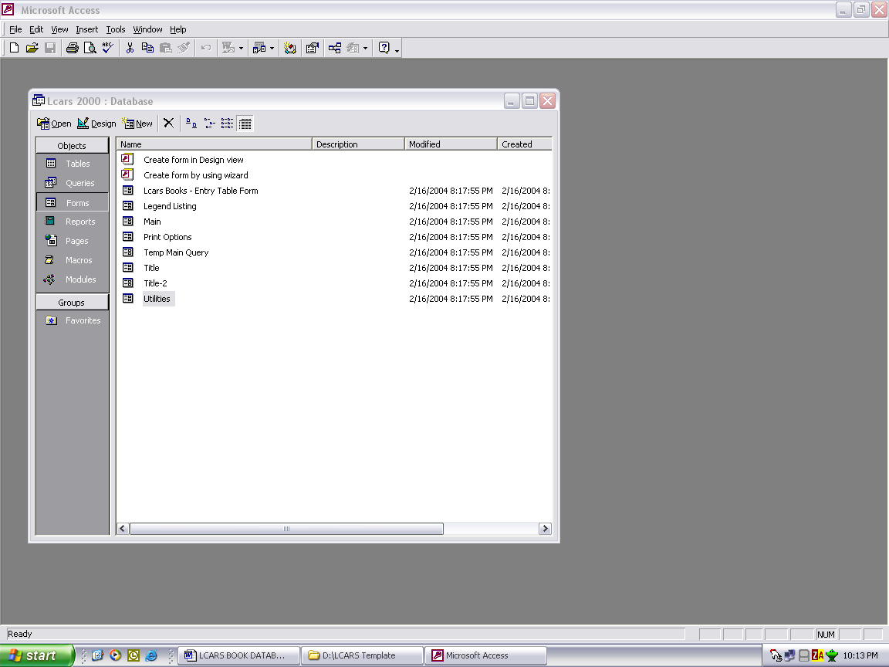

Click on ‘File’ on the main menu bar, then ‘Get External Data’ then ‘Link Tables’. A dialogue box will appear at which point you’ll want to navigate to where the ‘LCARS 2000-images.mdb’ file is stored. Double-clicking on the file should open another dialogue box that lists a number of tables. Click on the ‘Lcars Books-Images’ table and hit ‘Ok’

You can now exit out of Access to allow the changes to save and take affect.

WARNING: Attempting to open the main dB file before linking the above table will cause an error.

Once you link the table, you can then re-open the ‘Lcars Books.mdb’ database for immediate use.

3. Navigation – Main Screen

After you’ve opened up the dB and the Federation welcome screen completes its set up process, you should be looking at the Main Navigation Window:

The main navigation window is just that – a navigation window. No changes/modifications can be made to the books in this view. It’s a read only screen. Book entries are made through the Utilities screen – See Section 4.

The main screen is set up in four quadrants. The first quadrant, in the upper left hand corner, contains the book title in large yellow letters. Below the title is a description of the series code. The LCARS dB comes pre-installed with several series codes including:

TOS – The Original Series
TNG – The Next Generation
DS9 – Deep Space Nine
VOY – Voyager
ENT – Enterprise
MS1 – Small Miscellaneous Paperback
MS2 – Medium Miscellaneous Paperback
MS3 – Large Miscellaneous Paperback
You have the ability to add an unlimited amount of series codes – see Section 4 for more on the LCARS dB Utilities)

Also in the first quadrant is a ‘Summary’ section where a summarized description of the book can be viewed. Finally, the first quadrant also lists the series code, book number (if any), and an indicator for whether the book has been read or not.

The second quadrant, which is in the upper right hand corner, contains the book image – if any – the condition of the book (Mint, Very Good, Good, etc…) the copyrighted date of the book and the printing.

The third quadrant, which is in the lower left hand corner, contains the book title again, this time in a smaller font, the author(s), and any comments you may want to list about the book. Also in this quadrant is a listing of the current date and time (Federation standard, of course).

Finally, in the fourth quadrant, which resides in the lower right hand corner, you have a series of command functions and a link to the other dB utilities. (See Section 4 for more on the Utilities). It also lists the total number of entries you have in the dB. When you first run the dB, the total entries will show as 1 because of the ‘welcome’ book that’s preloaded. To delete this book, see Section 5.

The four (4) command functions allow you to maneuver around the dB listing. You can move forward or backwards through your records, or you can perform a search on one or all fields within the dB. Finally, the dB exit command is here as well.

4. dB Utilities

The Utilities screen is where you’ll do most of your data entry and dB set up. To access the Utilities screen, simply click on the Utility menu:

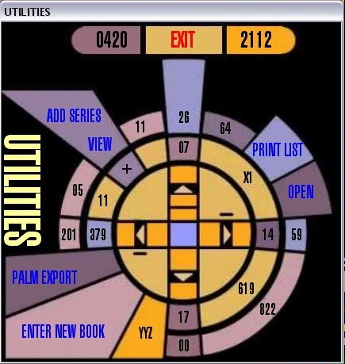
The Utility Screen has several, listed options on it.

EXIT: To exit the Utilities screen, click on the red EXIT button on the top of the screen.

ADD SERIES: To Add a new series code, simply click on this button and follow the simple on-screen instructions. Once added, a new screen will pop up, displaying all of your series codes and the number of entries listed for each.

VIEW: You can also simply view this screen without adding a new series code by clicking on the ‘VIEW’ button right below the ‘Add Series’ button.

PALM EXPORT: Clicking this button will do two things. It will set up two tables called ‘Palm Book Export Table’ and ‘Trek Book List TXT’. It will also save a text extract of the ‘Trek Book List TXT’ to your root hard drive location (e.g. C:\) named TREKLIST.txt I use Mobile dB to load the ‘Palm Book Export Table’ on to my Palm PDA, but you can use alternate dB programs as well to either link to one of these two tables, or to import the exported text file. Future versions of the LCARS dB will allow for exports to Excel, MS-Word and HTML formats.

PRINT LIST: You can print your book list in two different modes – one with images, one without. A list with images will only place 13 titles per page while the version without images will fit 58 titles per page.

ENTER NEW BOOK: This is where it all happens. The entry screen is set up to allow you to easily enter in the information for your new book. Some fields, like the title and series code and Read? Indicator are required – others are not. Working from top to bottom, and maneuvering using the ‘TAB’ key, you simply enter your series code from the drop-down list menu, then select the ‘Read?’ indicator (Yes/No), then either enter in a book # or delete it out. Next, enter in the book title and a summary (if desired). Next, you can enter in any comments about the book in the appropriate field, as well as the book’s author, copyright date, condition (from a drop down menu) and printing. Finally, if you so desire, you can insert a picture of the book by right-clicking in the box directly below the ‘copyright’ date box.

Right-clicking will open up a windows dialogue box and should present you with an option to ‘Insert Object’. Click on ‘Insert Object’ and then select your object type. Only a few of these will work and properly display an image in MS-Access. If you wish to scan the book in, select the ‘Microsoft Photo Editor 3.0 Scan’ option. If you wish to load an image from a file, select the ‘Microsoft Photo Editor 3.0 Photo’ option.

In either case, load/scan the image and set it up to be approximately 1 ½ inches high. This will result in an optimally displayed image and take the least amount of disk space. Once done, exit the Photo Editor software, which will return you to the ‘Book Entry Screen’. You should now see a small version of the image in the box. Don’t worry if it looks distorted right now – it’ll look better in a minute.

If you’re ready to process the book, click on the large Trek emblem – the dB will do the rest. Congratulations! You’ve just entered in your first book. To properly load the image and set other parameters up, once you ‘process’ a new book, the dB will automatically exit the utilities screen and re-load the dB. A future version will hopefully return you back to the Utilities or Entry Screen for a more efficient means of entering multiple books.

At any time if you want to exit the Entry Screen without processing the book, simply click on the red EXIT button at the bottom of the screen.

5. Deleting/Changing Data.

At this time, I have not completed a process to help you delete or modify a book’s information easily. But both of those options will be available in the next version of this system (which will be available in Spring 2004 – fingers crossed). In the mean time, if you wish to modify any part of the book’s information, you’ll need to do so directly in the dB. The table that contains the main data is called, aptly enough, LCARS Books. You can change any information in this table BUT TAKE CARE WHEN CHANGING THE BOOK’s TITLE. This table links, via a query, to the table you linked from the Image database. If you change a book’s title in one table, you MUST change it in the other. Failure to do so will result in the main dB being out of synch with its image counterpart. The result is that the images will not be viewable on the main screen. So please be careful! This is why I want to build a proper sub-system that manages the links for you.

The same goes with deleting an entry. The option doesn’t exist now, but if you wish to delete a book, like the first one listed when you loaded the software, you must delete the entire entry from both the LCARS Books table and the LCARS Books-images linked table. Warning: Do NOT delete this entry until you have made at least one other entry into the dB. The dB will not function at all unless at least one book entry is present, which is why it came pre-loaded.

That’s about it. Have fun and enjoy and by all means, feel free to contact me with any questions, problems, concerns, suggestions or just to say ‘Hi’. You can reach me at jpatuto@virginmobileusa.com or jag2112@earthlink.net or you can Instant Message me via Yahoo on Jaguar2112.

Live long…

-John

